Biodiversity
What is biodiversity?
According to Cardinale et al. (2012), biodiversity refers to variability among living things across all the sources of the earth including marine, terrestrial and aquatic ecosystems in addition to ecological composites to which they belong. This includes the diversity between species, within species and of ecosystems. Biodiversity comprises the foundation of the large group of ecosystem services that essentially contribute to the wellbeing of human beings.

How do humans’ activities threaten biodiversity?
Biodiversity is facing adverse threat due to human activities. The biodiversity is endangered because of population increase and usage of resources. Furthermore, urbanization and habitat conversion are the other threats that are threatening the extinction of biodiversity. The population growth in my community is alarming and as a result, the limited resources are being overexploited which has resulted in environmental degradation.

Are there nature reserves in your community? What are they protecting?
Yes. The nature reserves present in my community include a forest reserve. The reserve protects the forest from being overexploited for products such as bioproducts, timbers, food and fuel. This forest is a critical part of the community as it plays functions such as nutrient cycling, air and water purification, carbon storage. Additionally, the forest is also a habitat for various wildlife.

What is the impact of biodiversity in your community?
Agriculture, fisheries and forestry products, potential natural water cycles, a balanced climate, fertile soils and many other critical ecosystem practices rely upon the preservation of biological diversity (Pereira et al., 2013). The production of food in my community depends on biodiversity for different food plants, pollination, provision of nutrients, pest control, genetic diversity and prevention and control of diseases. Loss of biodiversity can lead to rampant transmission of ailments to human beings. Consequentially the healthcare cost will go high. Therefore, biodiversity underpins economic activities.

What steps can you take to protect biodiversity?
Through the implementation of simple habitat proactive activities such as helping native pollinators is key to reducing serious environmental impacts subjected to the environment (Pearce & Moran, 2013). Pollinators are useful in reproduction in flowering plants which are basic needs to the survival of numerous species on the earth. So, I can give pollinators a survival boost in my backyard through the refraining from using pesticides, planting different wildflowers and native plants that will provide nectar sources. The wildflowers and native plants may bloom over the entire season, leaving the rocks and logs in my backyard as well as building bee boxes to attract native bees to make habitat. I can also start a campaign in my city to avoid weed-whacking sidewalks and median strips edges and allow wildflowers to thrive to create pollinator corridors. Reusing and recycling the compost is another significant way to conserve the environment. I will encourage my community members to cut the amount of waste thrown into the landfills. I will encourage the use of recyclable products in my community. Another great step I can take is to minimize my energy demand. Combustion of fossil fuels adversely affects the climate. Consequentially it leads to the loss of biodiversity. I will begin a home energy audit to raise awareness in the areas I can reduce the consumption of energy.
An environment's biodiversity is determined by the number of different species of plants and animals that inhabit it. The sample size can be as large as a forest or as small as your backyard. It can even be just a handful of earth. Show the biodiversity in your community through a series of images. Take a minimum of five (5) pictures of biodiversity in your community. Discuss the type and what it means to the ecosystem.
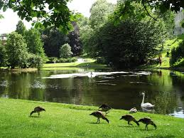
A well-maintained environment is a home for insects which is food for other species like ducks.
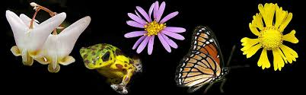
The flowers store nectar for butterflies. Butterflies also facilitate the pollination process in plants hence plants can make their own food through photosynthesis
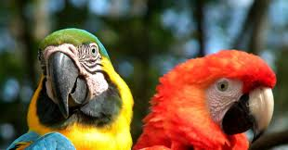
The birds are part of the biodiversity and they make the environment beautiful

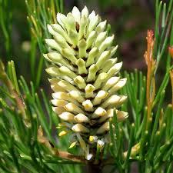Native weeds make the environment beautiful and facilitate aeration in the atmosphere through absorption of carbon dioxide from the atmosphere
Biodiversity examples

These are species diversity and ecological diversity. These diversities are essential in maintaining the correct balance of nature.

Biodiversity Loss
While you are out exploring, take note of any biodiversity loss. Take two (2) pictures of biodiversity loss in your community. Example: This could be logging of trees for a new housing development or clearing trees for a new store.
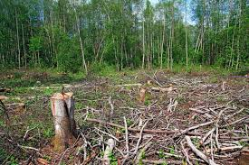
Cutting of trees to create space for human settlement has depleted the habitat for many wildlife

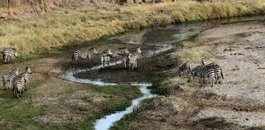
Insufficient water and greens for wildlife to eat due to logging

Biomes
Explore your community for biomes. Take pictures of a minimum of two (2) biomes. Write a description of the biome and clearly label what type of biome it is. What is the value of the biome to the community?
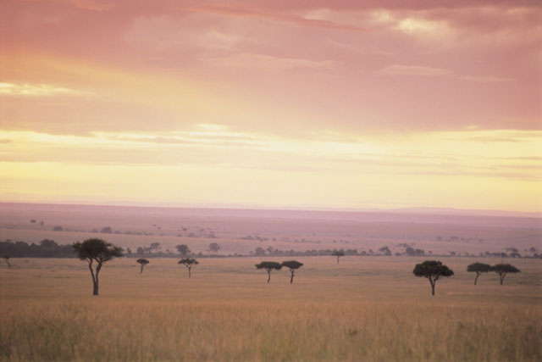
Desert biome
The desert biome is valuable to the community as it attracts hundreds of tourists every year. This brings economic growth to society.

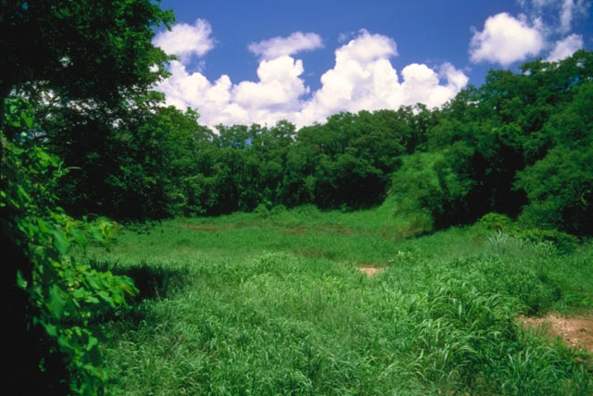forest biome
The forest biome is essential for survival of human beings as it purifies the air human beings breath. The wood used in building of furniture is obtained from the forest

Forest biome

References
Cardinale, B. J., Duffy, J. E., Gonzalez, A., Hooper, D. U., Perrings, C., Venail, P., ... & Kinzig, A. P. (2012). Biodiversity loss and its impact on humanity. Nature, 486(7401), 59.
Pearce, D., & Moran, D. (2013). The economic value of biodiversity. Routledge.
Pereira, H. M., Ferrier, S., Walters, M., Geller, G. N., Jongman, R. H. G., Scholes, R. J., ... & Coops, N. C. (2013). Essential biodiversity variables. Science, 339(6117), 277-278.
Schulze, E. D., & Mooney, H. A. (Eds.). (2012). Biodiversity and ecosystem function. Springer Science & Business Media.

